Theme 5

The Birth of Rugby League

Pupil Resource Sheet 4

Cartoon Satire

1. The Rugby Rumpus
This cartoon is set outside King James’ Grammar School, Almondbury, where the Reverend Frank Marshall was headmaster. The caricatures of Marshall, who opposed broken-time payments, and James Miller, president of the Yorkshire Rugby Football Union who supported broken time payments, ridicule the divide in rugby. The gate post is engraved with: ‘ALMONDBURY GRAMMAR SCHOOL FOR YOUTHS OF INDEPENDENT MEANS ONLY’. The book he is holding is called ‘PURITY OF FOOTBALL’.

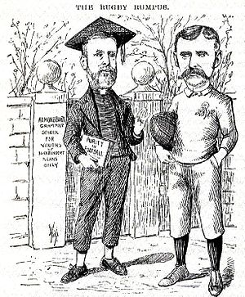

Marshall: Oh, fie, go away naughty boy, I don't play with boys who can’t afford to take a holiday for football any day they like!

Miller: Yes, that’s just you to a T; you’d make it so that no lad whose father wasn’t a millionaire could play at all in a really good team. For my part I see no reason why the men who make the money shouldn’t have a share in the spending of it.

2. Professionalism

The Reverend Frank Marshall, caricatured as Mrs Partington, who was famous for trying to sweep back the tide of the Atlantic

